CIS451 FINAL PROJECT

ONLINE STORE

Using

SQL/PHP

BY:

BIN LI

**2.**

**Table of Contents:**

Page URL

Summary

Logical Design

Physical Design

List of applications

User Guide

Contents of the Tables

Implementation Code

Conclusion

3.

Page URL:

<http://ix.cs.uoregon.edu/~ybl/finalproject/binliFinal.html>

username: guest2

password: guest2

port: 3496

hostname: ix.cs.uoregon.edu

4.

Final Project Part 1

In this PHP project, I’m going to create a database of potential items that could be sold online. This database will consist of possible things that can happen in a potential real life online business. I’m going to use the data to calculate certain outcomes of different sales, like profits, fees, and shipping costs. My CHEN diagram currently has eight entities which consists of information on how much items costs, shipping costs of items, shipping fees, the cost of sourcing certain items. There are many other different things that can happen to a sale of an item, like an item cancelation, or an item return which I would like to collect data on.

Some of the specific things I want to calculate is: I want to calculate the profits that can be generated from a sale or multiple sales, while considering the shipping costs and selling fees. I also want to calculate the how often an item is returned or go unpaid. I will also calculate the percentage of the sale or sales that goes towards fees and shipping, and if an item lose money on a sale. I believe there are many more things I can add to this model but these are the main things I want to focus on in this project.

5.

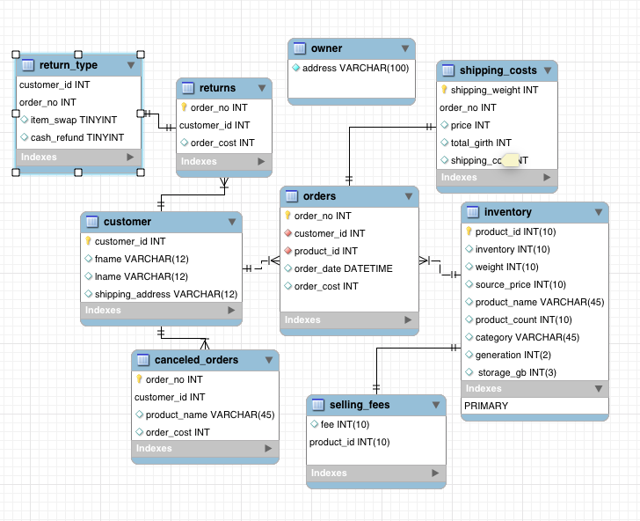

**6.**

**SQL function queries and its applications:**

**orders**: The primary key is order_no, this is the main location where you would keep track of the orders that come in.

**custome**r: list of all customers that purchase something. The primary key is customer_id

**returns**: The customers will return things, this is where you keep track of what customers return and money that gets refunded to buyers.

**return_type**: Tells you if the item is returned for an item swap or a money back.

**Canceled_orders**: This will tell you the orders that get canceled before it was shipped and the amount that needs to get refunded.

**Shipping_costs**: given the order number, this will keep track of the shipping cost.

**Inventory**: all possible items that is in stock, with detailed description of the specifications of the item.

**Selling_fees**: given the product_id, this is where you’d keep track of all the selling fees using product_id

**Owner**: The owner of the store.

**7.**

**All SQL function queries and tables each effect:**

Search for a product name(word) and see if we have it: inventory

Top of Form

Bottom of Form

Search for an order number and see the product name and how much we profit: inventory, orders, shipping_costs, selling_fees

Top of Form

Bottom of FormSearch for a product id and see how many of the item we have:

Inventory

Top of Form

Bottom of FormSearch for the selling fee of the products id:

Inventory, selling_fees

Top of Form

Bottom of Form

Total items in inventory: inventory

Top of Form

Bottom of Form

Total orders: orders

Top of Form

Bottom of Form

Total returns: returns

**8.**

How to use the queries I created:

Search for a product name(word) and see if we have it: search for a product name (eg: ipod, bose)

Top of Form

Bottom of FormSearch for an order number and see the product name and how much we profit: Input an order number 1-10

Top of Form

Bottom of FormSearch for a product id and see how many of the item we have: Input a product id 1-10.

Top of Form

Bottom of FormSearch for the selling fee of the products id: input a product id 1-10

Top of Form

Bottom of FormTotal items in inventory: just click the button to see

Top of Form

Bottom of Form

Total orders: click the button to see

Top of Form

Bottom of Form

Total returns: click the button to see

**9.**

Mysqldump can be found on website link on the bottom of the page

**10.**

Implementation code could be found on the website link on the bottom of the page.

**11.**

In this project, I have created an implementation of a mini online selling business, like one that I operate in real life. It does basic tasks like calculate profit, and displays your inventory. If this project implemented the right SQL queries, I can benefit from these functions in real life. If I had more time, I would add better SQL queries, and create a better-connected crowfoot diagram using MySQL. I would want to simulate exactly how my actual business runs, and it would help my business by creating a platform where I can easily calculate what I need.